## **Project Happiness**

Prepared by:

Lisa Cannon

Xuancong Tran

Monica Ramos

Our team chose the topic because we wanted to discover the basis of measuring and understanding subjective well-being. Our team decided to work based on the World Happiness report that supports the United Nations on happiness and human well-being.

Levels of happiness varies throughout the world. There are likely many factors that influence the level of happiness in a country. We seek to determine some factors that could be used to predict happiness.

* This study seeks to determine:
  + How is happiness distributed around the world?
  + What are some of the factors influence happiness?
* While we can determine several factors that are predictive of happiness, there are many other factors that are not considered and are beyond the scope of this study.

World Happy Index by Country

How is happiness distributed in the world?

Happier countries are concentrated in Europe, The Americas and Oceania, leaving Africa and Asia with the lower scores.

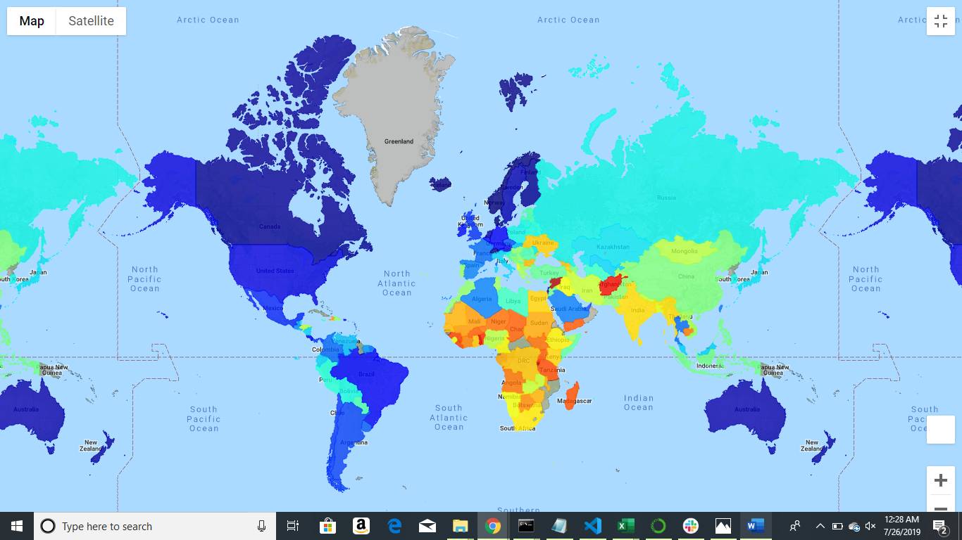

Happy Index Over time

How has happiness changed over time?

Finland, Norway, Denmark, Iceland and Switzerland are the countries with the higher Happiness Index score in the world and they have consistently ranked at this level for 2015 to 2018.

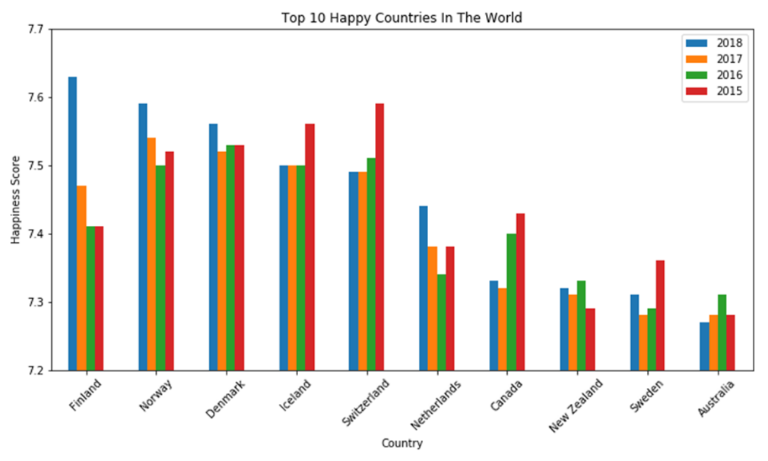

Happiness Distribution by Continent

Does happiness vary by continent?

The distribution of Europe and North America appear to be similar. The mean of South America is close to Europe and North America. The distribution of Africa’s happiness score is much lower than other continents.

Variable Analysis

Happiness and Country GDP

Log(GDP) has some relationship with the happiness score. Correlation coefficient is 0.5549. Wealthier countries tend to be happier.

Happiness and Population

There is no relationship between population and the happiness score.

The number of people I a country and how close they live to each other does not affect happiness.

Happiness and Country Median Age

There is some relationship between the median age in a country and its happiness score.

A higher median age indicates that people live longer and are likely healthier.

This indicates good health and a longer life increase happiness.

Happiness and Country Alcohol Consumption

Surprisingly, alcohol consumption has a positive correlation with happiness Index. Alcohol consumption has always been linked to be used to numb pain and despair. Also, linked to crime, violence, accidents and death. However, in this graph we can see that residents of happy countries probably consume alcohol for reasons like pleasure, indulgence and celebration.

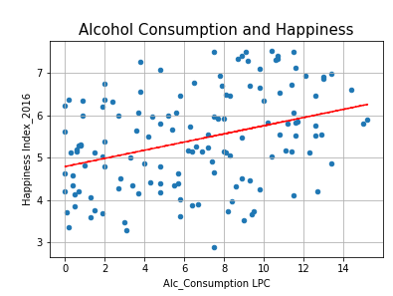

Happiness and Country Education level

This chart shows that happier nations have a higher Education index than unhappy ones with a strong correlation of 0.760. We can assume that Education is linked to sense of individual empowerment, community contribution and better job conditions. All of it contributing to country residents’ sense of security and wellbeing.

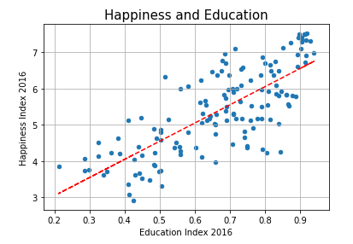

Happiness and Country Internet Access

This chart shows that happier nations have more accessibility to internet. This could be linked to country policies for freedom of speech and country telecommunication infrastructure due to geographical difficulties. Countries with lower happiness index tends to fall behind in the digital distribution of the access to, use of, or impact of information and communication technologies.

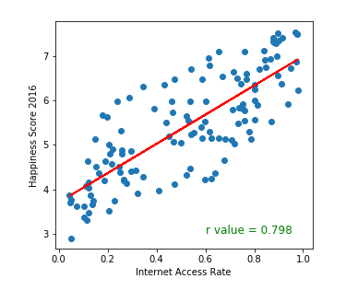

Variables with minimum or no correlation to happiness index

With these charts we can see there is a very small relationship between Happiness Index vs Disaster Rate and Average Sleeping Hours.

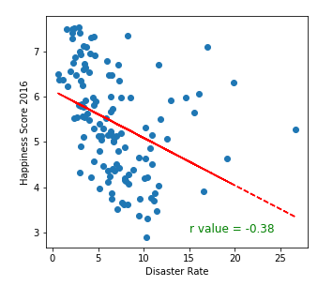 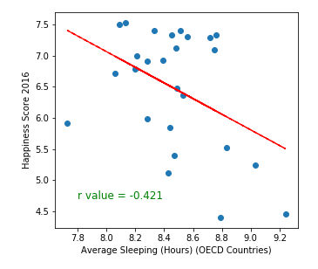

Conclusions

We can conclude that higher Happiness Index around the world is concentrated in Europe, The Americas and Oceania, leaving Africa and Asia with the lower scores.

Finland, Norway, Denmark, Iceland and Switzerland are the countries with the highest happiness score in the world, and they have consistently been ranked high for 2015 to 2018.

Further analysis should be conducted to draw any conclusions about how happiness nearby countries impact each other.

Factors with **strong correlation** to country happiness score:

* + Median Age, Education Level, Access to Internet.

Factors with **some correlation** to country happiness index:

* + GDP/PPP, Alcohol Consumption, Disaster Risk rate, Average Sleep

Factors with **no correlation** to country happiness index:

* + Population.